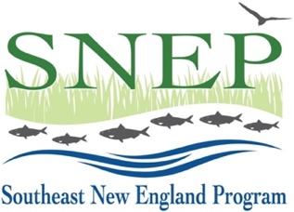
SWIG24 Full Proposal
Work Plan Template

This form is required for submittal with the Full Proposal. It supplements, but does not replace, the application questions. Use this document to provide more specific information on tasks, timelines, task leaders and major deliverables. Fill it out, save as PDF and upload where indicated on the Full Proposal application – 2 pages max.
Notes:
- Assume Oct. 1, 2024 Start Date (Month #1)
- Latest completion date Dec. 31, 2026 (Month #27)
- List each contract as a separate task
- Include QAPP development, if needed, as a separate task
- Add or subtract rows as need be
- First row filled out as example only – please delete.

Project Name:
Applicant Organization:
Expected Project Duration (months):
Task # | Description | Start & Completion (month # -- #) | Task Leader (org) | Major Deliverables
0 | BMP Construction | 6 - 12 | Skipjack Consulting (contract) | 6 bioretentions installed
1
2
3
4
5

