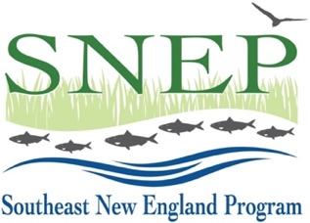
2024 SNEP Watershed Implementation Grants (SWIG24)
Full Proposal Application
Project Impact Model Template & Examples

Instructions: Many SWIG grants fund components of long-term or large-scale efforts, and even the smaller projects that we fund may have benefits that extend well beyond the immediate impact of the grant, temporally and geographically. The purpose of this document is to assist RAE, EPA and the SWIG Application Review Committee in understanding how your SNEP request fits into the big picture of restoring Southeast New England’s coastal and watershed ecosystems.

Create a simple process model that places your request within the large-scale effort to restore the regional environment as described in the SNEP Strategic Plan. Use yellow to indicate the stage of the project for which you are requesting SWIG24 funding. You may use any software to create the graphic, but you must upload it to the portal as an 8.5 x 11 inch PDF.

Here are several examples of the kinds of models we’re looking for, for different types of projects:

Example 1: Storm water construction funding

Example 2: Wetland restoration (design & permitting)

Example 3: Municipal Water Quality Ordinance – Special Management District

Comments (Optional):

